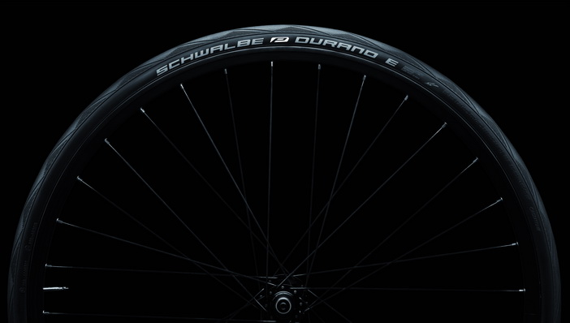

Sleek and aerodynamic, suitable for everyday use: The Durano E
for sporty E-bikers, approved up to 50 km / h
Photo: Schwalbe

Race tires for sporty electric bikers
You can see that the tyre has descended from the racing arena: The Schwalbe Durano E is the fastest tire for e-bikes. „With the reduced semi-slick tread we are talking to sporty pedelec riders who just appreciate the reliability of low rolling resistance during tours and for everyday cycling, "says René Marks, Schwalbe Product Manager for Touring. Because it is important for sports e-bikes to have good grip, Schwalbe chose a very sticky rubber compound that provides optimum grip when cornering, even when wet. Reflective strips and a puncture protection belt also contribute to security.
Schwalbe offers the Durano E in five sizes and two versions: as a particularly lightweight folding tire (from 335 grams) in sizes 28-622 and 32-622 with Dual Compound and reflective labels. And as a clincher version (495 grams) with reflective strips in sizes 32-622, 37-622, 40-622 and 40-584. All tires carry the ECE-R 75 mark for fast e-bikes valid throughout Europe. Price: 29,90 € for the clincher and 39.90 euros for the folding.

This press release with photos and Graphics can be downloaded from: www.schwalbe.com/en/presse.html

SCHWALBE - Ralf Bohle GmbH  Doris Klytta
Otto-Hahn-Straße 1  51580 Reichshof-Wehnrath
Telefon: +49 2265 109-57  Fax: +49 2265 7022
d.klytta@schwalbe.com  www.schwalbe.com

